Amelia Cui 260824815 P2

Part I Relational Model

Updated E/R model:

Updated relational model:

Person (HIN, RegDate, city, name, postalcd, phone, streetAddress, gender, cname)

* cname foreign key referencing relation Category

Category (cname, pLevel)

Nurse (NLN, nursename, locname)

* locname foreign key referencing relation Hospital

Hospital (locname, lcity, lpostalcd, lstreetAddress)

VaccineLocation (lname, lcity, lpostalcd, lstreetAddress)

VaccineLocPerDay (vacdate, lname)

* lname foreign key referencing relation VaccineLocation

Slot (vslot, vtime, vacdate, lname)

* (vacdate, lname) foreign key referencing relation VaccineLocPerDay

Vaccine(vname, waitingPeriod, numdoses)

VaccineBatch (numvails, expdate, bnumber, manudate, vname)

* vname foreign key referencing relation Vaccine

Vail (vnum, bnumber, vname, vslot, vtime, vacdate, lname)

* (bnumber, vname) foreign key referencing relation VaccineBatch
* (vslot, vtime, vacdate, lname) foreign key referencing relation Slot

nurseAssignments (NLN, vacdate, lname)

* NLN foreign key referencing relation Nurse
* (vacdate, lname) foreign key referencing relation VaccineLocPerDay

personAllocation (alloc_date, HIN, vslot, vtime, vacdate, lname)

* HIN foreign key referencing relation Person
* (vslot, vtime, vacdate, lname) foreign key referencing relation Slot

batchStorage (bnumber, vname, lname, sentDate)

* (bnumber, vname) foreign key referencing relation VaccineBatch
* lname foreign key referencing relation VaccineLocation

Part II Pending constraints

* When assign a person a category, we have to manually check the category stored is the one with highest priority (pLevel) if a person belongs to several categories
* When a slot is created at a VaccineLocPerDay, the personAllocation must be created based on the pLevel for the category that cname is associated with the person (connected to personAllocation by HIN)
* We have to manually make sure that when a vail injection is created, at least one nurse assignment must exist for the vaccineLocPerDay associated with the slot where the injection happened.
* We have to manually check that the sentDate in batchStorage must be before the vail injection slot date and time that the vails inside each VaccineBatch is injected
* We have to check that the number of vail relations for each VaccineBatch must be less that the numvails attributes in this VaccineBatch
* For the personAllocation relation for each person, if there are more than one slot associated with him/her, the vail injection happened at these slots must belong to same vaccine name, which can be acquired by VaccineBatch relation, and must be less that the numdoses for that vaccine. Additionally, the vacdate difference between these slots must be greater than the waitingPeriod for the vaccine.
* For each vail injection, the date of the slot associated with it must before the expdate of the vaccineBatch associated with it.
* The vail can only be created if the personAllocation for the slot associated with the vail is not null.
* The database system does not prevent 2 people choosing the same slot, which should not be allowed in reality.
* Assume that the person must be successfully injected once personAllocation is created (there cannot be invalid personAllocation); the instance of personAllocation has to deleted from database if a person wants to cancel the appointment
* The regDate for each person must be before the data and time for the slot that is associated with the personAllocation for that person (can be accessed by the HIN for a given person)
* For each slot associated with a given vail injection, the number of personAllocation associated with the vaccineLocPerDay that is associated with the slot must be less than or equal to the number of nurse assignments associated with that vaccineLocPerDay.

Part III SQL Queries

1. select vslot, vtime, vacdate, lname  
   from Slot  
   where lname = 'Jewish General' and vacdate = '2021-03-20'  
   except  
   select vslot, vtime, vacdate, lname  
   from personAllocation  
   where lname = 'Jewish General' and vacdate = '2021-03-20'  
   ;

1. select expdate  
    from VaccineBatch  
    where (bnumber, vname) in (  
    select Vail.bnumber, Vail.vname  
    from Vail, personAllocation  
    where Vail.vacdate = '2021-02-06'  
    and Vail.vacdate = personAllocation.vacdate  
    and Vail.vtime = personAllocation.vtime  
    and Vail.lname = personAllocation.lname  
    and Vail.vslot = personAllocation.vslot  
    and personAllocation.HIN in(  
    select HIN  
    from Person  
    where name = 'Jane Doe'  
    )  
    )  
   ;

1. select COUNT(HIN) as totalNum  
   from personAllocation  
   where vacdate = '2021-02-06'  
   and (vacdate, vslot, vtime, lname) in  
   (  
    select vacdate, vslot, vtime, lname  
    from Slot  
    where Slot.lname in (  
    select lname  
    from VaccineLocation  
    where lcity = 'Montreal'  
    )  
    )  
   ;

1. select name, phone, HIN  
   from Person  
   where HIN in (  
    select HIN  
    from (  
    select HIN, COUNT(*) as counts  
    from personAllocation, Vail  
    where personAllocation.vacdate = Vail.vacdate  
    and personAllocation.lname = Vail.lname  
    and personAllocation.vtime = Vail.vtime  
    and personAllocation.vslot = Vail.vslot  
    and Vail.vname = 'Pfizer-BioNTech'  
    group by personAllocation.HIN  
    ) as temp  
    where temp.counts =1  
    and HIN in (  
    select HIN  
    from personAllocation  
    where vacdate < '2021-02-01'  
    )  
    )  
   ;

1. select count(*) as counts, cname  
   from Person  
   where HIN in (  
    select distinct HIN  
    from personAllocation  
    )  
   group by cname  
   ;

//assume that the question was asking for all records of person that are injected or planned to be injected for each category. (Or we may need to check the date information for personAllocation to be before current time)

Part IV Montreal Nurses

* View definition:

create view mtlnurses (NLN, nursename, locname, lcity, lpostalcd, lstreetAddress)  
as select NLN, nursename, Nurse.locname, lcity, lpostalcd, lstreetAddress  
 from Nurse, Hospital  
 where Nurse.locname = Hospital.locname  
 and Hospital.lcity = 'Montreal'  
;

* Screenshot of successfully created view
* 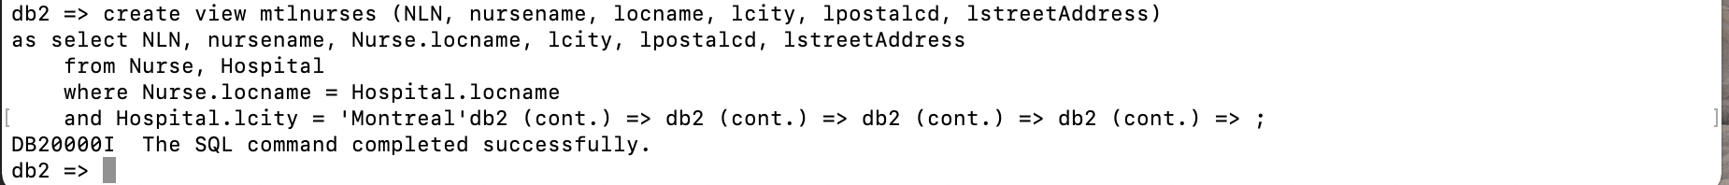
* Screenshot of selecting 5 records from view

Query:

select *  
from mtlnurses  
limit 5

* 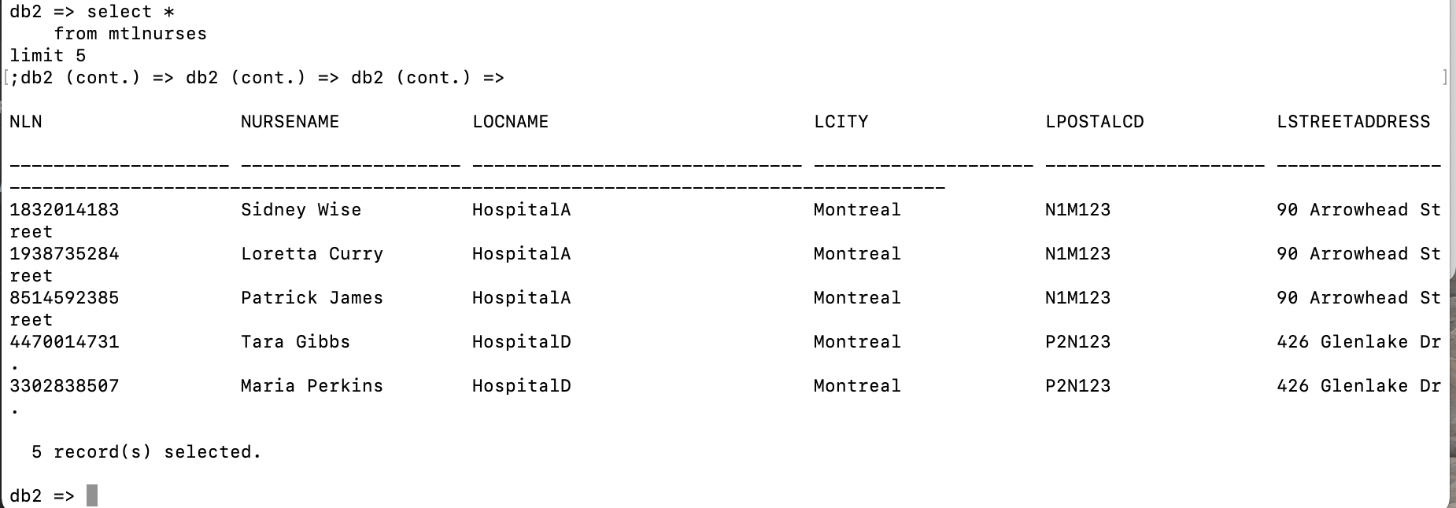
* Screenshot of selecting 5 records from nurses that are employed at “Jewish General”

Query:

select *  
from mtlnurses  
where locname='Jewish General'  
limit 5

* Screenshot of the insert command

* Explanation:

As shown above, the insert cannot be successfully executed. It is because the view we created is not a valid table. The view is just created for our convenience to get certain combinations of data in database. It is not created to store data, instead, it is created based on “actual” table in database, therefore, we cannot perform “insert” operation on a view.

Part V: Check Constraints

* Screenshot of the check constraint



* Attempt to insert an invalid record

It is a failure because it violates the constraint that the expdate of a VaccineBatch must be past its manudate.